# Final Report

### Project: iWillGo

1. Introduction

The idea of this project is a website where people can decide how do they want to spend their leisure time.

Users can create events which other people can join to. When creating, author can specify the place and the date of the event. Users can add each other to their friend lists. Each event can be commented on by anyone.

1. Design and Implementation

The project is implemented as MEAN stack application, which is hosting by IBM Bluemix platform.

The server side contains two models User and Event and two route handlers for them. Also the application is using Twitter Bootstrap JS framework.

I was thinking how to implement the ability to choose the location of the event and then I found pretty good solution which is NgMap. Unfortunately, there are some features I haven’t implemented yet, such as tag selection.

In my implementation I used this list of JS libraries:

jquery.min.js - jQuery library is using to hide collapsible menu on blur

angular.min.js - AngularJS library

ng-map.min.js - NgMap library

angular-ui-router.min.js - AngularJS UI router library

angular-resource.min.js - AngularJS resource library

ui-bootstrap-tpls.min.js - UI bootstrap library is using to organize date selection

ngDialog.min.js - is using to show login/registration dialogs

bootstrap.min.js – frontend JS framework

The client part of application contains one module named iwgApp which contains a set of services and controllers.

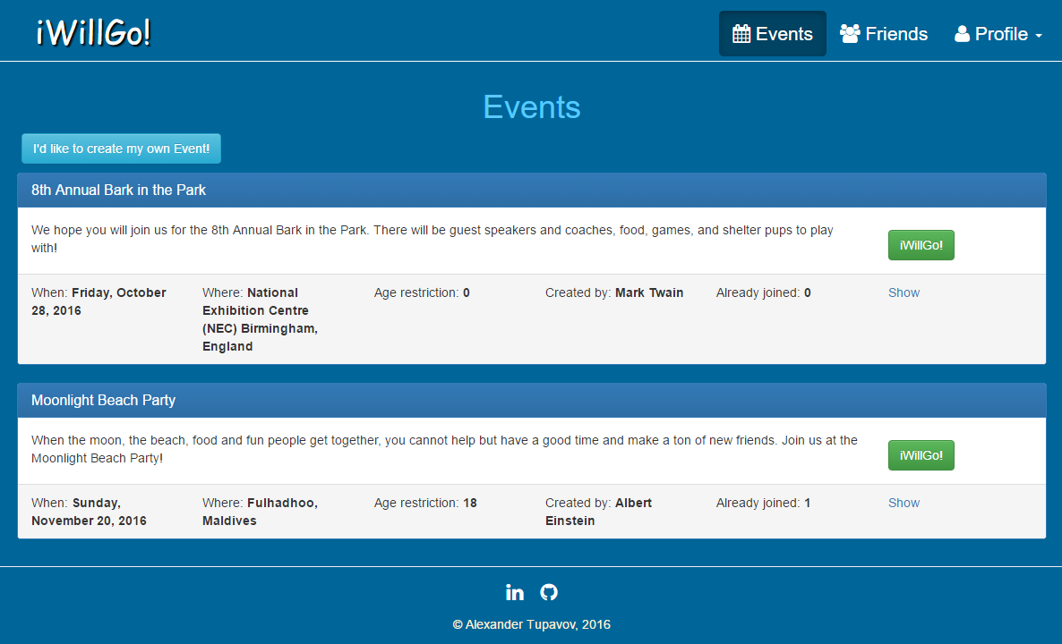

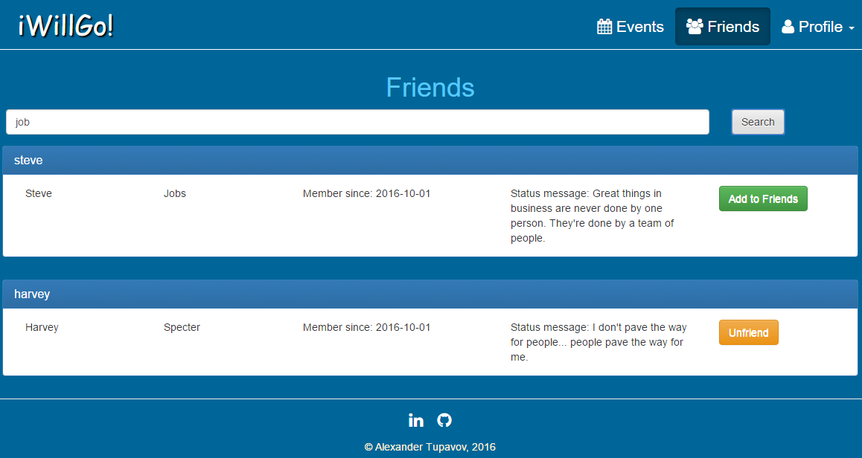

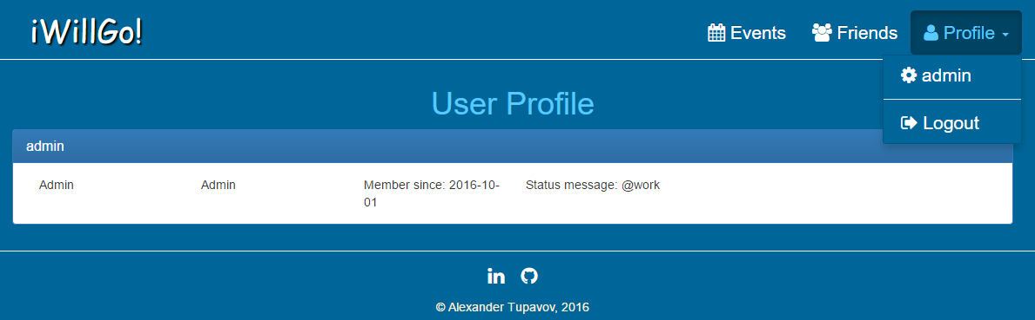

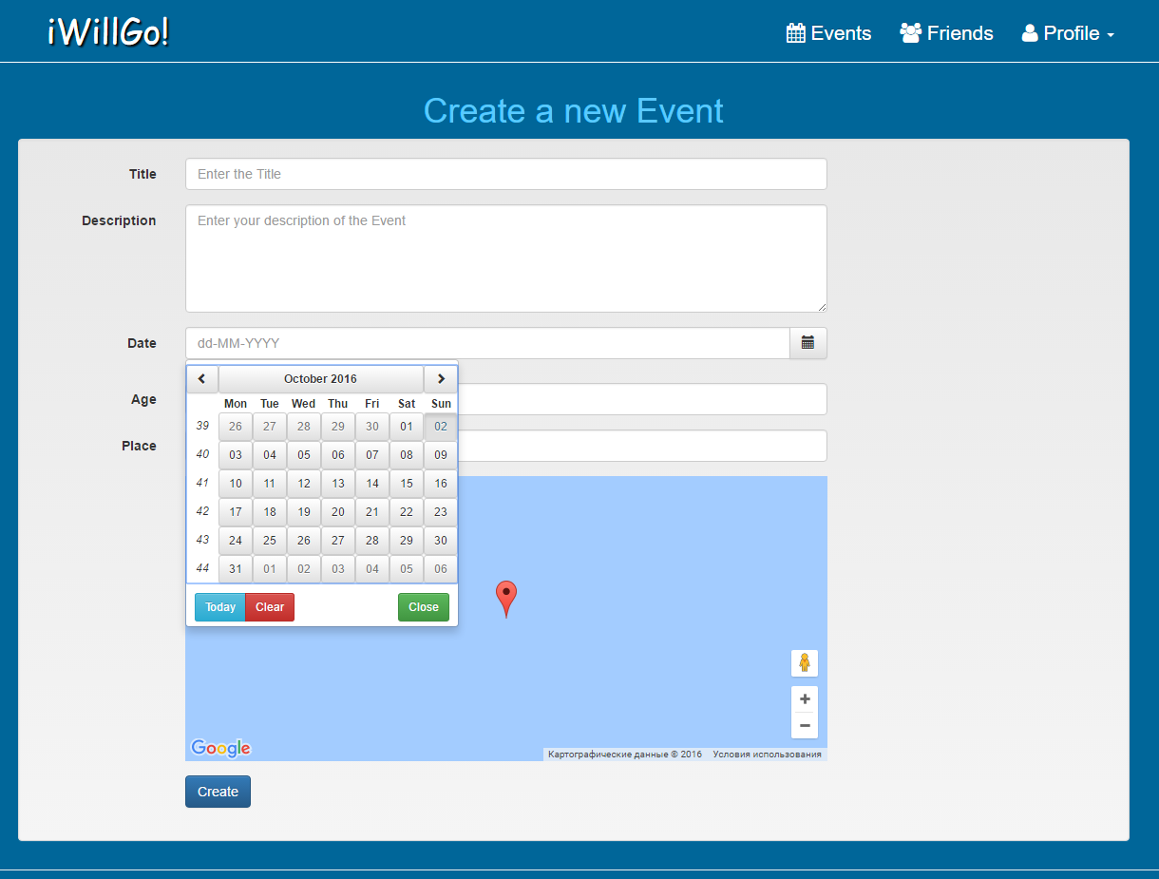

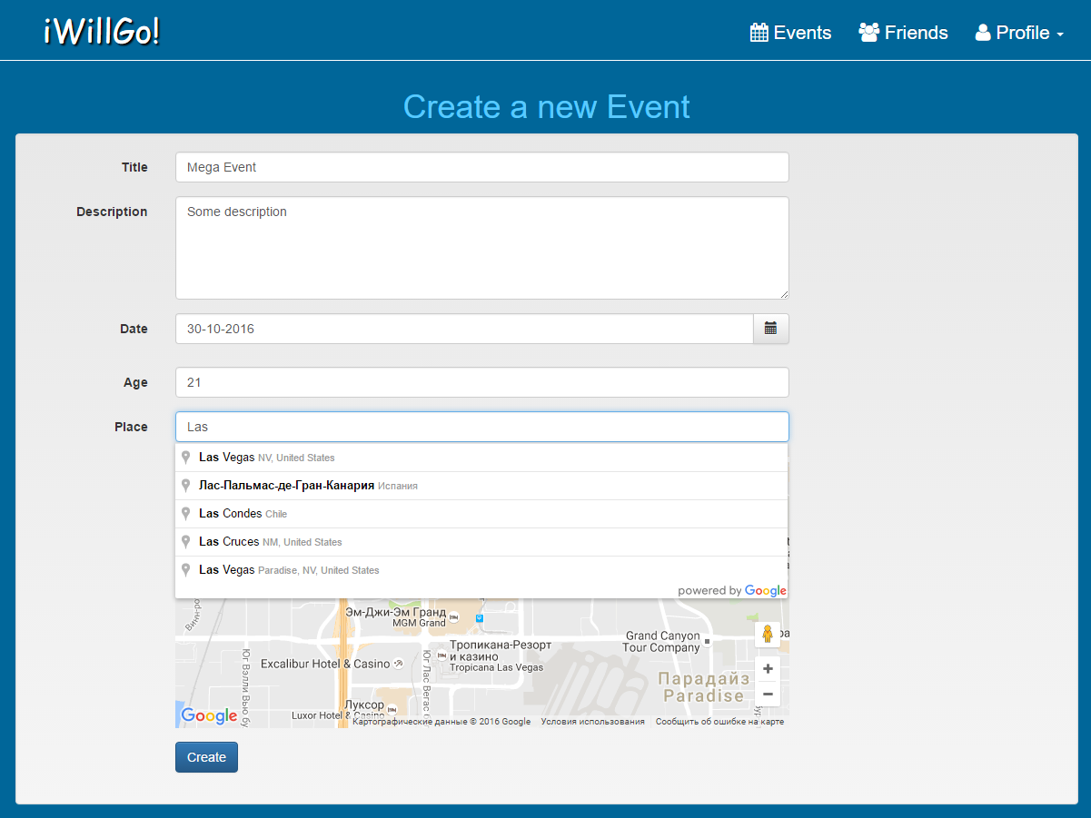

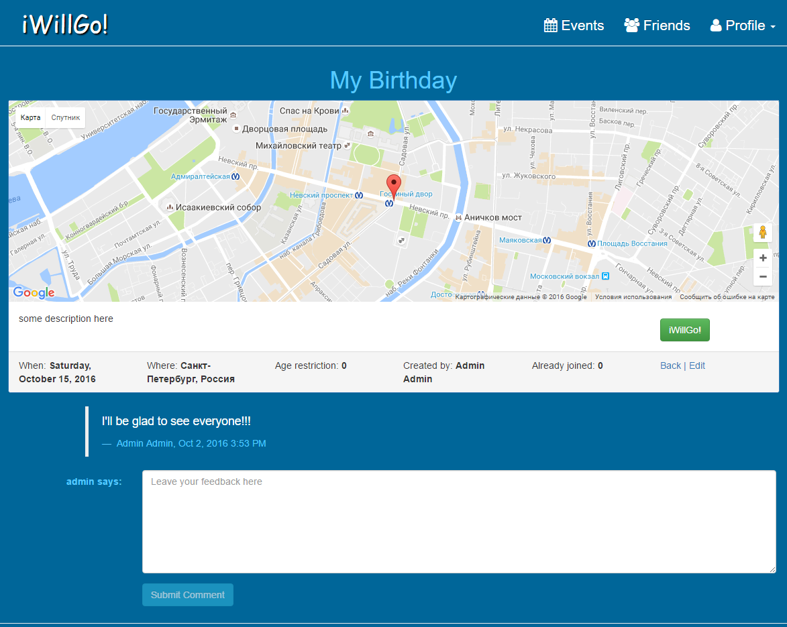

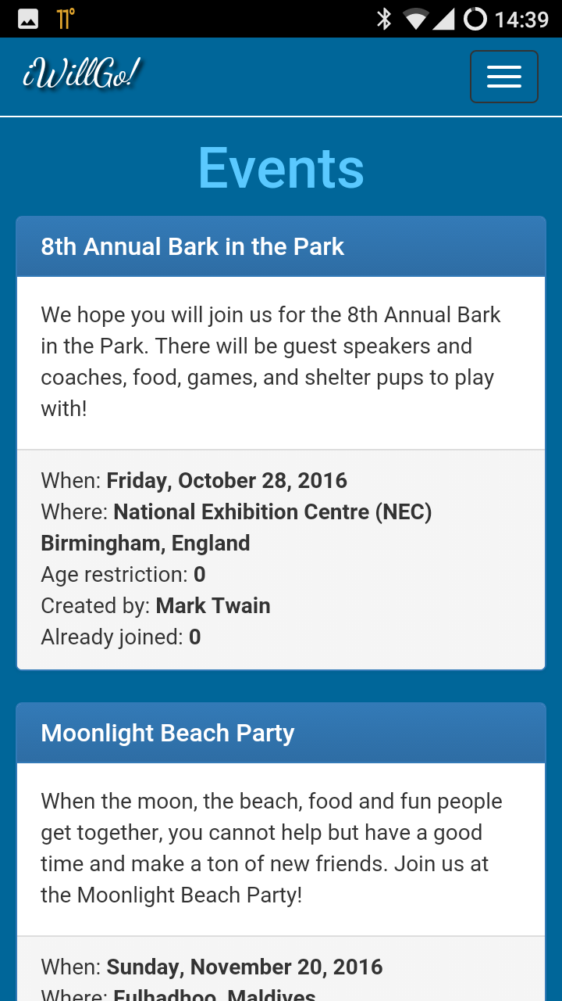

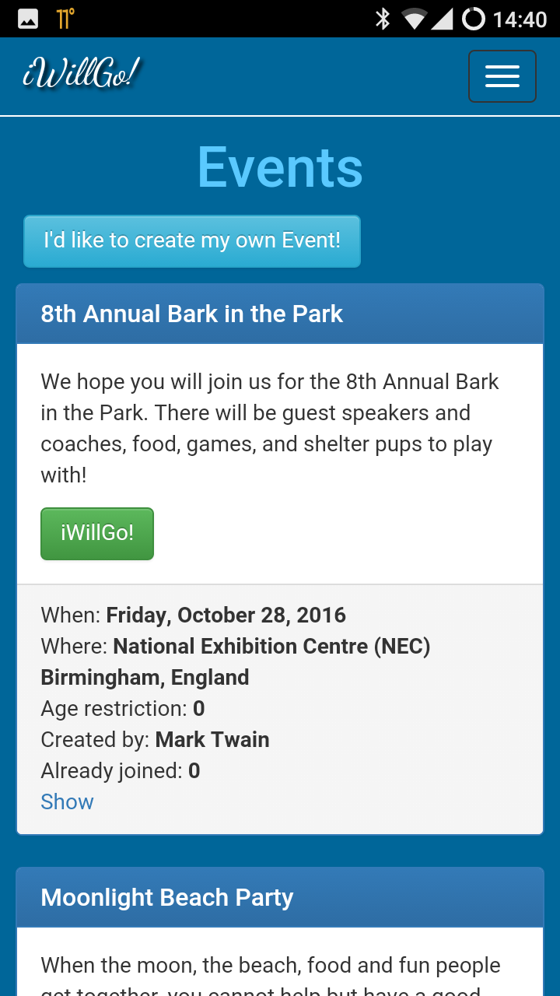

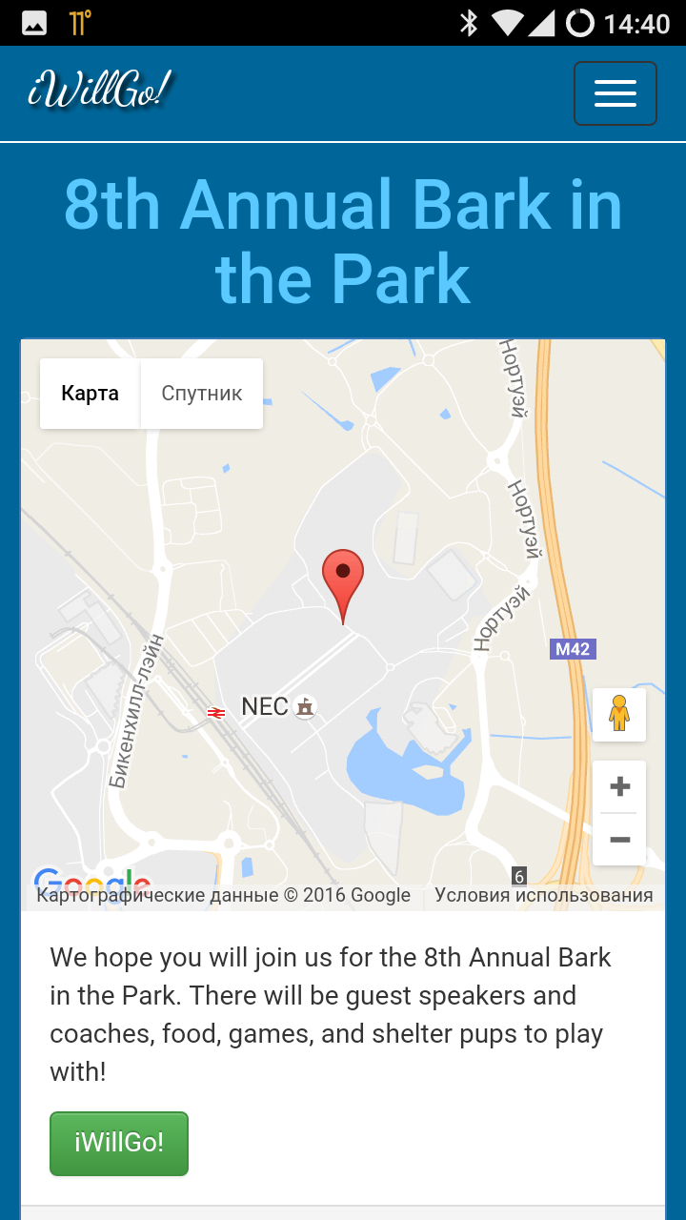

1. Conclusions

It really was great experience for me!

1. References

* <http://iwillgo.mybluemix.net/>
* <https://github.com/tauinbox/iwillgo-bluemix>
* <http://getbootstrap.com/>
* <https://ngmap.github.io/>
* <https://angular-ui.github.io/bootstrap/>